**Table of Contents**



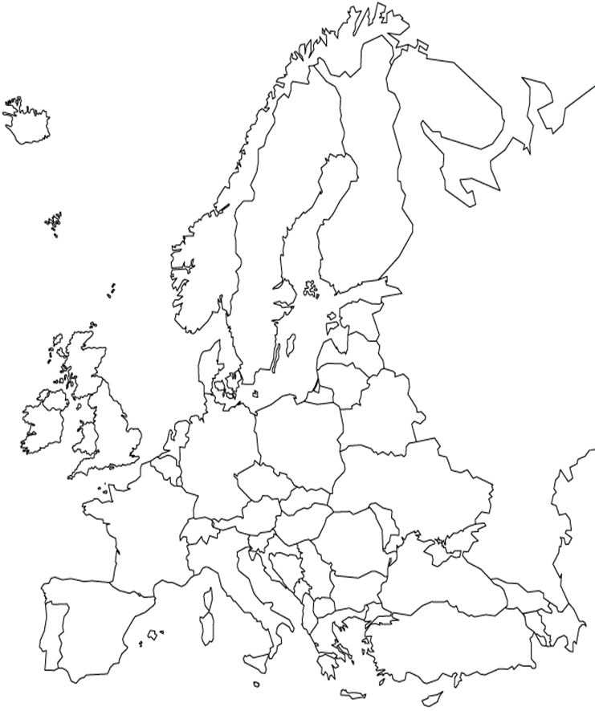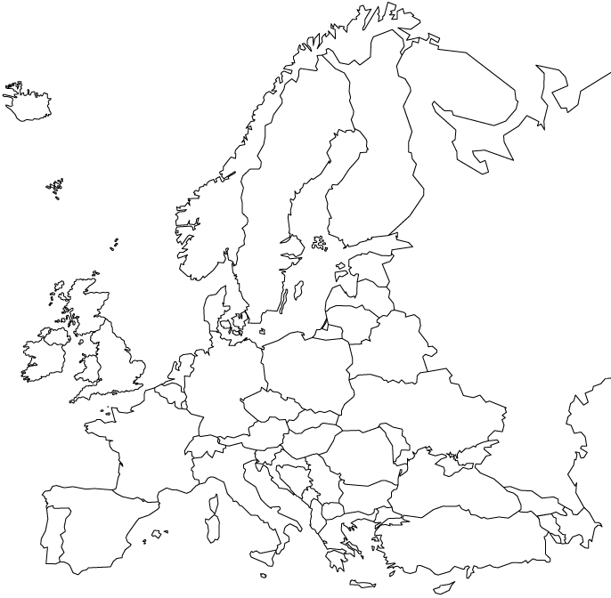

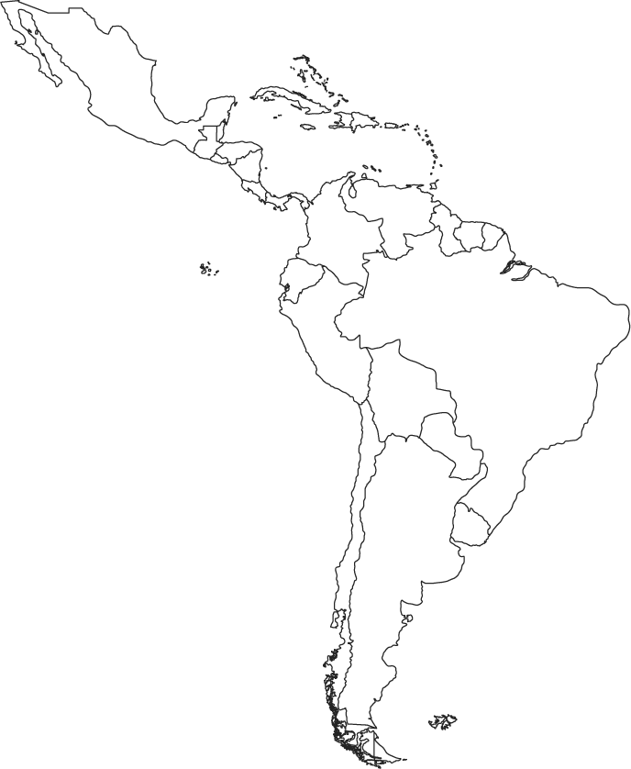

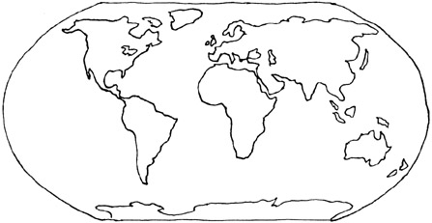

**What are the first four things**

**you look at on a map?**

**What are four things that impact climate?**



**What are the four cardinal directions?**

**What intermediate directions?**

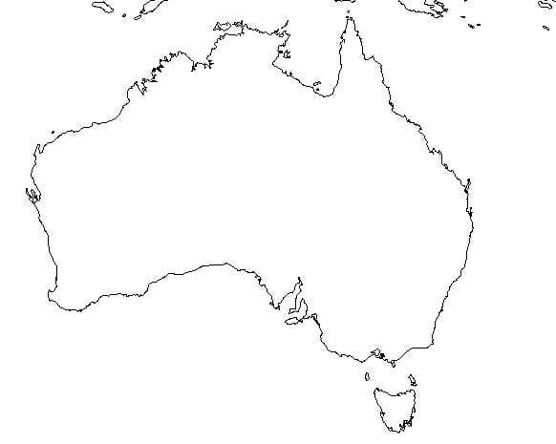



**6th Grade Atlas**

**Mr. Satell’s Class**

Name:

Date:

Period: